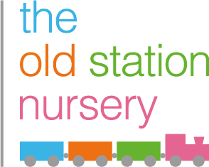

1 Month Free Childcare in December 2024

Terms and Conditions:
- Must register and start nursery between Monday 1st July and Monday 30th September 2024 to receive one month free in December 2024
- The discount will be applied to invoices for December 2024 and will be based on the number of starting sessions in the first week (settling in sessions completed prior to 30th September 2024)
- Limited availability applies; only available nursery sessions or spaces will be offered, and once full, the offer will no longer be available
- This offer is only valid for permanent booking patterns
- Other discounts or offers are not applicable during this period and will be applied after the promotion ends
- Available across all The Old Station Nursery Group nurseries and Little Green Rascals Organic Day Nurseries
- By taking up the offer, you agree to be bound by these terms and conditions.

