Little Ndaba

Ndaba, is a common word in Africa that means a gathering, usually joyous and social. So your purchase goes a long way towards spreading this joy.

A growing group of women on the outskirts of Lusaka, Zambia, gather once a week to wash and sew knitted and crochet pieces into the beautiful toys that you see on this site. They share skills and advice as well as enjoy the chance to catch up on each other’s news! Before leaving, they collect more cotton and return home once more to knit and crochet additional pieces for the following week’s production. For many of the women, who come from a totally rural background, this provides their only opportunity to contribute to their family income, while at the same time allowing them to work around their home and farming commitments.

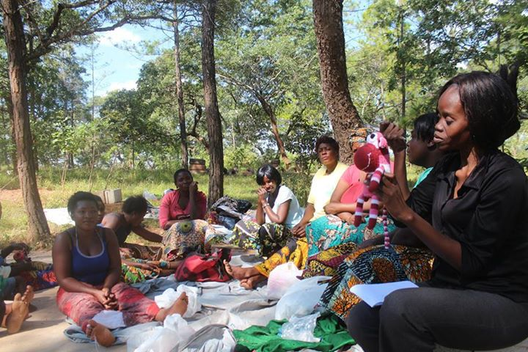

The Ladies
Pictured top left are Mary, who makes the knitted cows, Martha who crochets giraffes and Margaret who does the lot. They are sitting outside Emily’s kitchen. The village is Palabana, near Lusaka, the capital of Zambia. The total number of women varies, but it’s usually around the 30 mark. Depending on the season, organizing is a permanent challenge as they also have to work the fields, prepare food and sometimes have to walk long distance to escort children to school. Zambia has a dry season, and a wet season when heavy rains can make life and getting together even more difficult.

The ladies come and go for various reasons. When they hear about the project it takes some courage to join as their village life is isolated, so a large group of women they don’t know can be a bit intimidating. To help ease this process they are split into groups where they can form stronger bonds and support. Sadly, Little Ndaba has lost a number of wonderful women because their husbands are jealous or threatened by their wives new found ability to make some money. Although the back drop of alcohol and other attendant problems is extremely difficult, strong role models do emerge and small victories are celebrated. This is the story of poverty, so your support is far reaching in every sense of the word and we thank you for your time reading this introduction to “the ladies”.

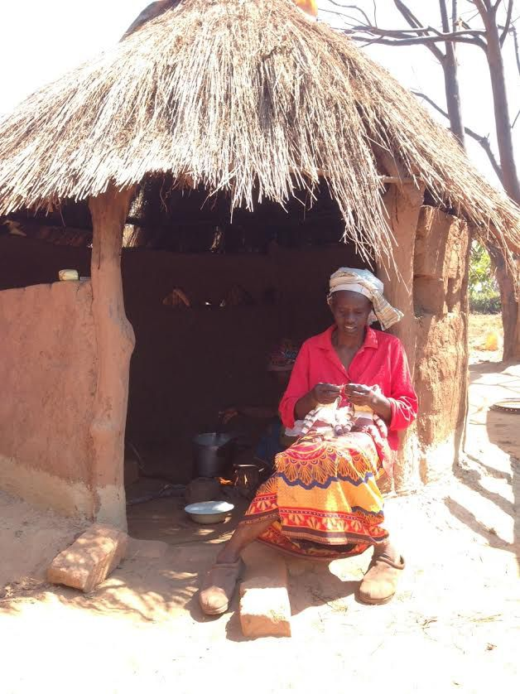

Emily, Church Minister and Widow.
Emily, pictured above, lives outside her church which she both keeps clean and is a minister of. She usually wakes around 4:00 a.m. as this is a quiet time to gather her thoughts and write her sermons with no one about to distract her. She looks after various nieces, nephews and grandchildren who come and go. Emily makes the lions and leopards mainly. She is a quiet but strong positive force among the group and is very supportive to the other women and Little Ndaba. As a widow, she is really reliant on Little Ndaba as selling her toys provides much needed income as she has very few other ways to make money.

Financial Needs
When asked, the ladies always quote school fees (many of the women cannot afford the uniforms that are required to send their child to a government school so use community schools instead, but there is still a small monthly fee. And when you have about 5 or 6 kids attending then it adds up), school shoes, books, mealimeal, and then occasionally there’s enough left to buy a new wig or chtenge (colourful traditional cloth they wear around their waists!) Sometimes some money is given to appease a sulky husband who can for cultural reasons, resent his wife having an independent income.

