Little Ndaba Animals
Meet the gang! (all are handmade in organic cotton)

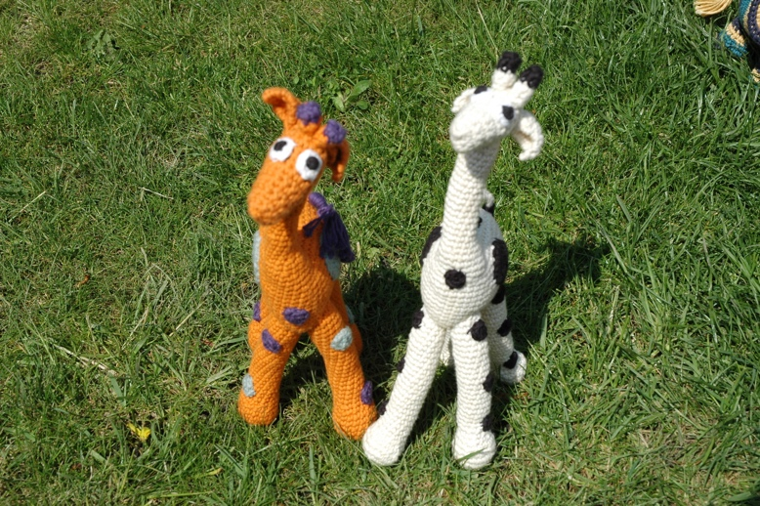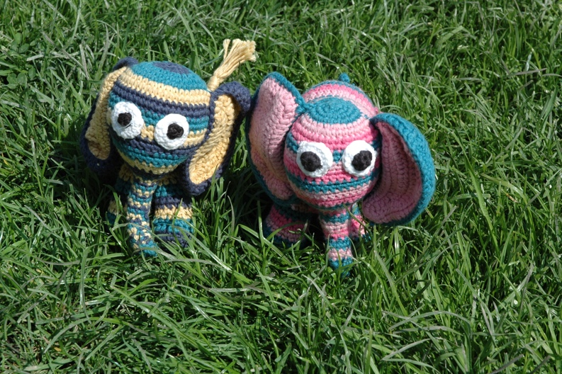
Crochet giraffe £17 Crochet elephant £18

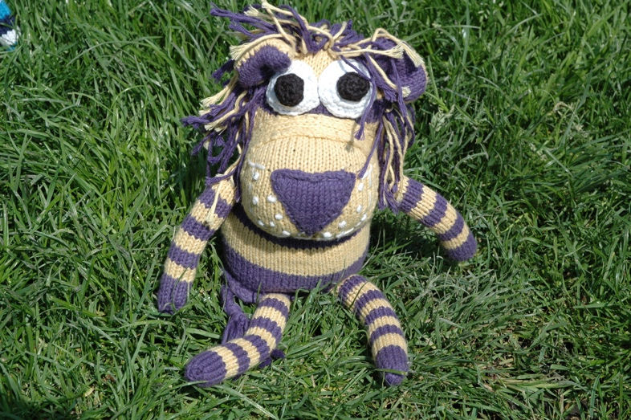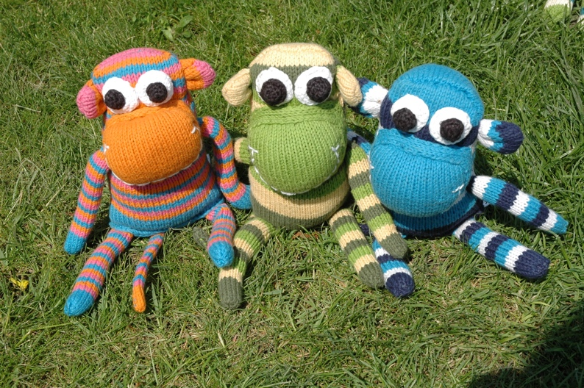
Knitted lion £20 Knitted monkey £19

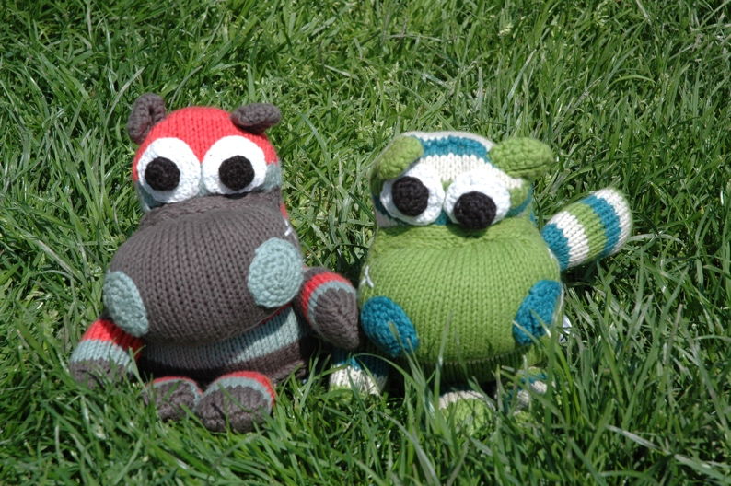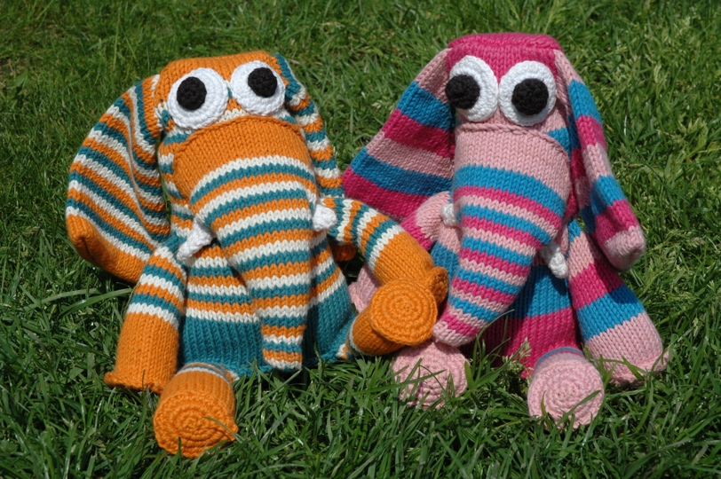
Knitted hippo £19 Knitted elephant (large) £21

All animals £3 post and packaging

