Safeguarding Policy

Purpose of Policy
We work with children, parents, external agencies and the community to ensure the welfare and safety of children and to give them the very best start in life. Children have the right to be treated with respect, be helped to thrive and to be safe from any abuse in whatever form.
We support the children within our care, protect them from maltreatment and have robust procedures in place to prevent the impairment of children’s health and development. In our setting we strive to protect children from the risk of radicalisation, and we promote acceptance and tolerance of other beliefs and cultures. Safeguarding is a much wider subject than the elements covered within this single policy, therefore this document should be used in conjunction with the nursery’s other policies and guidance, such as Whistle Blowing, Mobile Phone and Electronic Devices Policy, Safer Recruitment and Suitability and Codes of Conduct.
Statutory Requirements (Early Years Foundation Stage, 2021)

3.4. Providers must be alert to any issues of concern in the child’s life at home or elsewhere. Providers must have and implement a policy, and procedures, to safeguard children. These should be in line with the guidance and procedures of the relevant local safeguarding partners (LSP).
3.5. A practitioner must be designated to take lead responsibility for safeguarding children in every setting. The lead practitioner is responsible for liaison with local statutory children's services agencies, and with the LSP. They must provide support, advice and guidance to any other staff on an ongoing basis, and on any specific safeguarding issue as required.
3.6. Providers must train all staff to understand their safeguarding policy and procedures, and ensure that all staff have up to date knowledge of safeguarding issues. Training made available by the provider must enable staff to identify signs of possible abuse and neglect at the earliest opportunity, and to respond in a timely and appropriate way.
3.7. Providers must have regard to the government's statutory guidance ‘Working Together to Safeguard Children’17 and to the ‘Prevent duty guidance for England and Wales’18. If providers have concerns about children's safety or welfare, they must notify agencies with statutory responsibilities without delay. This means the local children's social care services and, in emergencies, the police.
3.8. Registered providers must inform Ofsted of any allegations of serious harm or abuse by any person living, working, or looking after children at the premises (whether the allegations relate to harm or abuse committed on the premises or elsewhere). Registered providers must also notify Ofsted of the action taken in respect of the allegations. These notifications must be made as soon as is reasonably practicable, but at the latest within 14 days of the allegations being made.
Legal Framework
- Children Act 2004
- Childcare Act 2016
- Safeguarding Vulnerable Groups Act 2006
- The Statutory Framework for the Early Years Foundation Stage (EYFS) 2021
- Working together to safeguard children 2018.

This policy also has regard for:
- Local Authority Safeguarding Children Board procedures (inc. procedure flowcharts to be used in conjunction with company procedures)
- Working Together to Safeguard Children (2018)
- Prevent Duty Guidance (2015)
- Female Genital Mutilation act (2003)
- Keeping Children Safe in Education (2020)
Policy

Definition
Safeguarding and promoting the welfare of children, in relation to this policy is defined as:
- Protecting children from maltreatment
- Preventing the impairment of children’s health or development
- Ensuring children are growing up in circumstances consistent with the provision of safe and effective care.
- Taking action to enable all children to have the best outcomes.

To Safeguard Children and Promote their Welfare we will:
- Create an environment to encourage children to develop a positive self-image.
- Provide positive role models and develop a safe culture where staff are confident to raise concerns about professional conduct.
- Encourage children to develop a sense of independence and autonomy in a way that is appropriate to their age and stage of development.
- Provide a safe and secure environment for all children.
- Promote tolerance and acceptance of different beliefs, cultures and communities.
- Help children to understand how they can influence and participate in decision-making and how to promote British values through play, discussion and role modelling.
- Always listen to children
- Provide an environment where practitioners are confident to identify where children and families may need intervention and seek the help they need.
- Share information with other agencies as appropriate.

Being Alert and Responsive

The nursery is aware that abuse does occur in our society and we are vigilant in identifying signs of abuse and reporting concerns. Our practitioners have a duty to protect and promote the welfare of children. Due to the many hours of care we are providing, staff may often be the first people to identify that there may be a problem. They may well be the first people in whom children confide information that may suggest abuse, or to spot changes in a child’s behaviour which may indicate abuse.

Recording

The nursery will maintain a record of any significant events or changes to child/family life using the Chronology of Significant Events record. These will be stored confidentially within individual child files and reviewed monthly by the setting DSL.

Responsibility

Our prime responsibility is the welfare and well-being of each child in our care. As such we believe we have a duty to the children, parents and staff to act quickly and responsibly in any instance that may come to our attention. This includes sharing information with any relevant agencies such as local authority services for children’s social care, health professionals or the police. All staff will work with other agencies in the best interest of the child, including as part of a multi-agency team, where needed.
Policy Aims:
- Keep the child at the centre of all we do.
- Ensure staff are trained right from induction to understand the child protection and safeguarding policy and procedures, are alert to identify possible signs of abuse, understand what is meant by child protection and are aware of the different ways in which children can be harmed, including by other children through bullying or discriminatory behaviour.
- Be aware of the increased vulnerability of children with Special Educational Needs and Disabilities (SEND) and other vulnerable or isolated families and children.
- Ensure staff understand how to recognise early indicators of potential radicalisation and terrorism threats and act on them appropriately in line with national and local procedures.
- Ensure that all staff feel confident and supported to act in the best interest of the child, share information and seek the help that the child may need.
- Ensure that all staff are familiar and updated regularly with child protection training and procedures and kept informed of changes to local/national procedures.
- Make any child protection referrals in a timely way, sharing relevant information as necessary in line with procedures set out by the Local Safeguarding Partners
- Ensure that information is shared only with those people who need to know in order to protect the child and act in their best interest.
- Keep the setting safe online using appropriate filters, checks and safeguards, monitoring access always.
- Ensure that children are never placed at risk while in the charge of nursery staff
- Identify changes in staff behaviour.
- Take any appropriate action relating to allegations of serious harm or abuse against any person working
- with children or living or working on the nursery premises including reporting such allegations to Ofsted and other relevant authorities.
- Ensure parents are fully aware of child protection policies and procedures when they register with the nursery and are kept informed of all updates when they occur.
- Regularly review and update this policy with staff and parents where appropriate and make sure it complies with any legal requirements and any guidance or procedures issued by the Local Safeguarding Partners.

We will support children by offering reassurance, comfort and sensitive interactions. We will devise activities according to individual circumstances to enable children to develop confidence and self-esteem within their peer group and support them to learn how to keep themselves safe.
Extremism – the Prevent Duty
Under the Counterterrorism and Security Act 2015 we have a duty to refer any concerns of extremism to the police (In Prevent priority areas the local authority will have a Prevent lead who can also provide support). Please see Prevent Duty Policy.
Monitoring children’s attendance
As part of our requirements under the statutory framework and guidance documents we are required to monitor children’s attendance patterns to ensure they are consistent and no cause for concern.
It is the responsibility of the Manager or DSL should a child not attend a session to make contact with the parents, if the absence continues over several days and we have not had a response and there is cause for concern then it is our responsibility to contact Local Safeguarding Partners.
Parents should inform the nursery prior to their children taking holidays or days off, and all sickness should be called into the nursery on the day, so the nursery management are able to account for a child’s absence.
This should not stop parents taking precious time with their children but enables children’s attendance to be logged so we know the child is safe.

Children with additional needs
Children who are the subject of multi-agency work may have additional needs. There are many reasons why children with challenging home lives may also have learning and/or behavioural needs as well.
Where children have additional needs, it is important that practitioners and the designated person take time to identify any barriers to learning. In some cases, it may be appropriate for other agencies to be involved in support. It may be necessary to conduct an EHA (Early Help Assessment) or other multi-agency meeting to find appropriate ways to support the child and the family.
Please refer to the SEND policy for further information on how to support children with Special Educational Needs and Disabilities.
Peer on Peer Abuse
Children can abuse other children, and this is referred to as ‘peer on peer abuse’ this can take many forms including those listed in the table above as well as bullying, sexual violence and harassment etc. Staff will raise concerns when there are issues of peer-on-peer abuse and DSL’s will consider what support might be needed for both parties.

Safeguarding young people (employees)
All members of Management are responsible for recognising that some Apprentices and employees, aged under 18, are a vulnerable group. Management are responsible for ensuring that vulnerable individuals are protected from abuse or harm. Management must therefore be vigilant for any signs of significant harm and avoidable danger including any unlawful discrimination, exploitation, access to a potentially unsafe learning environment, bullying, self-harm, FGM and neglect.
In the event of an Apprentice or young person presenting evidence of the above, either verbally or in writing, Management must do the following.
- Tell the young person that we may not be able to guarantee that anything they disclose to us, which may be covered by our safeguarding policy, will be treated as confidential as we have an overriding Duty of Care to ensure their wellbeing is safeguarded and to report any areas of concern we identify.
- Ask them to detail the facts and take notes of exactly what was said. Management must not ask leading questions.
- Refer the case to the Designated Safeguarding Lead who will refer the case to the appropriate Area Manager and HR as appropriate.
Private Fostering
Private fostering is an arrangement made between the parent and the private foster carer, who then becomes responsible for caring for the child in such a way as to safeguard and promote his/her welfare. A privately fostered child means a child under the age of 16 (18 if a disabled child) who is cared for and provided with accommodation by someone other than:
- A parent
- A person who is not a parent but has parental responsibility.
- A close relative.
- A Local Authority.
for more than 28 days and where the care is intended to continue. It is a statutory duty for us to inform the Local Authority via MASH where we are made aware of a child or young person who may be subject to private fostering arrangements.

Procedure – What to do if you are concerned about a child’s welfare or safety

In the event of concerns about a child’s welfare or safety, follow the ‘what to do if you have concerns about a child’s welfare or safety’ flowchart IMMEDIATELY
All members of staff to co-operate with our local safeguarding teams, police, and Ofsted in any way necessary to ensure the safety of the children. It is IMPORTANT to follow the Local Authorities process.
The named DSL(s) for this setting are: insert name/s
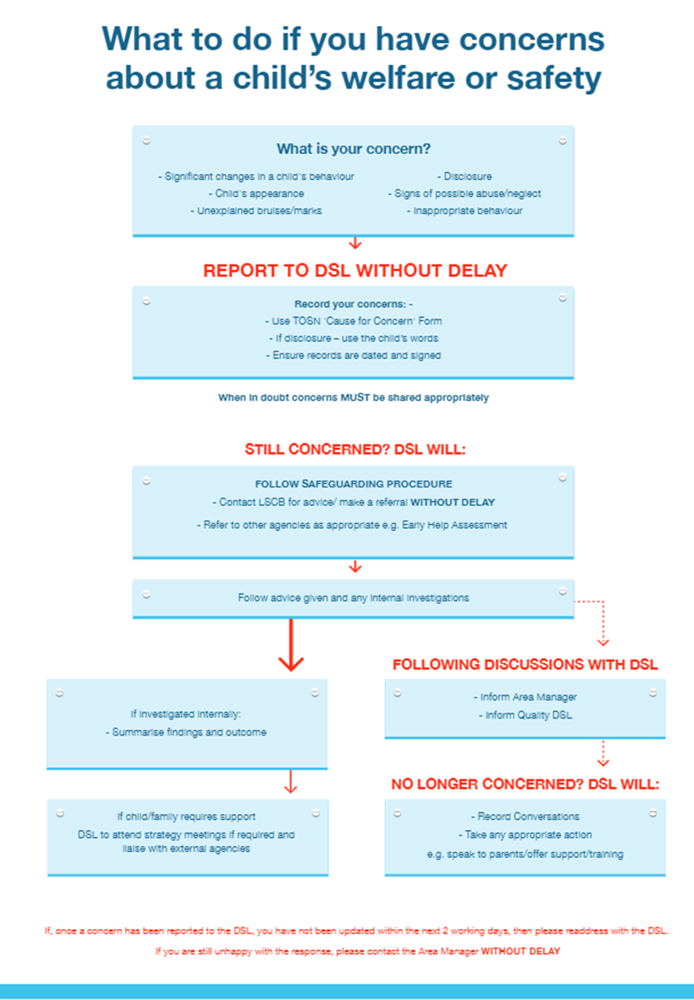

Procedure – What to do if an allegation is made against an adult

In line with our Whistle Blowing Policy and Code of Conduct, if an employee sees or suspects inappropriate behaviour by a member of staff or visitor at any level within the business, they have the responsibility and a duty of care to IMMEDIATELY remove the child/ren from risk of harm and then IMMEDIATLEY follow the ‘what to do if there is an allegation against a member of staff’ flowchart below.
The LADO (or Local Authority equivalent) will then be informed immediately or without failure within 24 hours of the allegation being made. Investigation WILL NOT commence unless instructed to do so by the LADO.
The named DSL(s) for this setting are: insert name/s
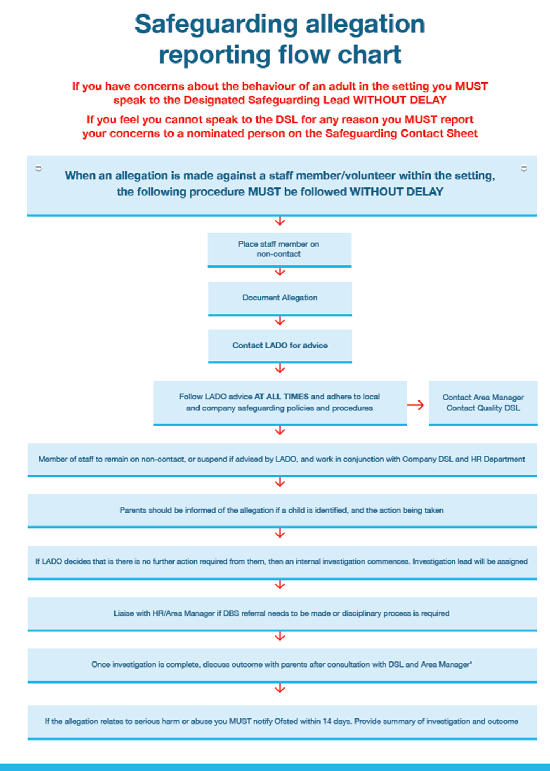
Inappropriate staff behaviour towards a child could include but is not limited to:-
- Rough or inappropriate physical handling.
- Force-feeding.
- Picking a child up in a way which causes injury or harm.
- Inappropriate language e.g. swear-words, racist comments, sexual comments and/or shouting.
- Inappropriate sharing of images.
- Excessive one to one attention with a child beyond the requirements of their usual role.

Reporting - Key Contact Details:

The Local Authority for the is Nursery is: | [insert Local Authority]
Local Authority MASH/Safeguarding team (or LA equivalent): | [insert telephone number]
Local authority Designated Officer (LADO) | [insert telephone number]
Ofsted | 0300 123 1231
Local Safeguarding Partners (LSP) | [insert telephone number]
Non-emergency police | 101
Government helpline for extremism concerns | 020 7340 7264

Disclosures and Recording Concerns

Disclosures
All staff should refer concerns to the Designated Safeguarding Lead (DSL) as soon as possible however in the meantime they should do the following when responding to a disclosure:
- Listen to the child, remain calm and offer reassurance.
- Observe bruises or marks trying to use naturally occurring opportunities to view any areas of concern such as during nappy changing.
- Allow the child to lead the discussion. Do not press for details and do not ask leading questions such as “what happened next?”
- Listen, do not investigate. It is ok to ask “is there anything else you would like to tell me?”
- Accept what the child says without challenge. Reassure them that they are doing the right thing.
- Don’t lay blame either with the child or the perpetrator.
- Don’t promise confidentiality; explain they have done the right thing in telling you. Explain who you need to tell and why.
- All staff should make records of any child disclosures or concerns through the following:
- Make brief notes of it immediately and as soon as possible complete the Cause for Concern Form. This must be completed with the support of your Designated Officer.
- Always use factual information only.
- Always use the child’s own language to quote, never translate into your own terms, or apply your own feelings or thoughts.
- The Designated Lead will respond to all concerns through the following:-
- Making any additional records required.
- Making a decision on whether to continue to monitor the situation or make a referral to LSP, if a referral is required this should happen immediately.
- Ensuring that any appropriate paperwork relating to the individual child is passed on to other settings or school if/when the child leaves with the knowledge of the parents/guardians.
- Storing recorded information from safeguarding meetings in a locked cupboard in a locked office.

Recording Process

- Staff should make an objective record of any observation or disclosure, using a Cause for Concern form
- Child's name
- Child's address
- Age of the child and date of birth
- Date and time of the observation or the disclosure
- Exact words spoken by the child
- Exact position and type of any injuries or marks seen
- Exact observation of any incident including any concerns reported, with date and time; and the names of any other person present at the time
- Any discussion held with the parent(s) (where deemed appropriate). These records should be signed by the person reporting this and the Manager/DSL, dated and kept in a separate confidential file.

- Chronology of Concerns Form are to be completed by the setting DSL and stored in the child’s individual file. Chronology to be reviewed every month by DSL.

- The nursery will maintain a record of any significant events or changes to child/family life using the Chronology of Significant Events record. A chronology is a tool that practitioners from a range of disciplines can use to help them understand what is happening in the life of a child, adult or family. It gives a clear account of all the major changes and significant events in the lives of the child(ren) and family.
All forms will be reviewed regularly by the setting DSL. The purpose of a chronology is to record significant events and changes for a child. It is not a running record of everyday events and should not replace case notes or records which include more detailed and sensitive information.
Chronologies are essential to:
  - Gain an overview of events and changes in the lives of the child(ren) and family.
  - Help practitioners understand the impact, immediate and cumulative, of events and changes on the child and family’s progress.
  - Provide accumulative evidence of emerging needs and risks and flag when a multi-agency response may be required.
- Support the early identification of patterns and issues. This supports, and is part of, assessing and managing risk, and is particularly useful in cases where there may be no single incident, i.e. in neglect.
  - Support assessment in considering past events and their relevance to the child and family’s current situation. To assist in the process of assessment, analysis, planning and review when working with a child, young person and family.
  - Strengthen working with children and their families and help a child and family make sense of their life.
What is recorded in a chronology?
The chronology provides a brief, factual record of significant events in sequential date order, and may include;
- Significant changes in the family structure, e.g. separation, divorce, bereavement, birth of a new sibling, new partner, presence of a significant adult, housing/home environment, unemployment
- Factual information and events including missed/child not to brought to appointments, when a child starts or moves school, missing school, exclusions, offending behaviour, changes in peer relationships, running away/missing from home
- Significant changes in the child or young person’s wellbeing
- Significant changes in the parent or carer’s wellbeing which impact on the child

Working with Families

It is important we make clear to parents our role in safeguarding their child. Parents should be encouraged to share information with us about accidents or concerns from home.
We have a responsibility to ensure we take reasonable steps to ensure that we do not hand a child over to a parent, guardian or authorised person if we suspect they are under the influence of alcohol or drugs. In this instance a member of the Management team will speak with the adult in question and request that they arrange for someone else to collect the child. Two team members will always remain with the child until an appropriate alternative collection can be arranged.
Informing parents of safeguarding concerns

Parents are normally the first point of contact. If a suspicion of abuse is recorded, parents are informed at the same time as the report is made, except where the guidance of the LSP/MASH/Safeguarding team/police does not allow this. This will usually be the case where the parent or family member is the likely abuser or where a child may be endangered by this disclosure. In these cases, the investigating officers will inform parents.
Support to families
The nursery takes every step in its power to build up trusting and supportive relationships among families, staff, students and volunteers within the nursery.
The nursery continues to welcome the child and the family whilst enquiries are being made in relation to abuse in the home situation. Parents and families will be treated with respect in a non-judgmental manner whilst any external investigations are carried out in the best interest of the child.
Confidential records kept on a child are shared with the child's parents or those who have parental responsibility for the child, only if appropriate in line with guidance of the LSP with the proviso that the care and safety of the child is paramount. We will do all in our power to support and work with the child's family.

Guidance for Recognising Signs and Symptoms of Abuse

Types of Abuse
Abuse and neglect are forms of maltreatment of a child. Somebody may abuse or neglect a child by harming them or by failing to act to prevent harm. Children may be abused within a family, institution or community setting by those known to them or a stranger. This could be an adult or adults, another child or children.
All staff must be aware of the main categories of abuse and can refer to Guidance for Recognising Signs and Symptoms of Abuse – types of abuse for more detail
- Physical
- Sexual
- Emotional
- Neglect
The signs and indicators listed below may not necessarily indicate that a child has been abused but will help us to recognise that something may be wrong, especially if a child shows a number of these symptoms or any of them to a marked degree.
Indicators of child abuse
- Failure to thrive and meet developmental milestones
- Fearful or withdrawn tendencies
- Aggressive behaviour
- Unexplained injuries to a child or conflicting reports from parents or staff
- Repeated injuries
- Unaddressed illnesses or injuries
- Significant changes to behaviour patterns.
We are aware that peer on peer abuse does take place, so we include children in our policies when we talk about potential abusers. This may take the form of bullying, physically hurting another child, emotional abuse, or sexual abuse. We will report this in the same way as we do for adults abusing children and will take advice from the appropriate bodies on this area.

Physical abuse

Action needs to be taken if staff have reason to believe that there has been a physical injury to a child, including deliberate poisoning, where there is definite knowledge or reasonable suspicion that the injury was inflicted or knowingly not prevented.
Many children will have cuts and grazes from normal childhood injuries. These should also be logged and discussed with the nursery manager or room leader.
Children and babies may be abused physically through shaking or throwing. Other injuries may include burns or scalds. These are not usual childhood injuries and should always be logged and discussed with the nursery manager.
Physical abuse can take various forms. In addition to the following examples, injury may be inflicted through means such as suffocating or poisoning.
- Bruises in places not normally harmed during play, for example, back of the legs, abdomen, groin area
- Bruising in or around the mouth area (especially in young babies)
- Bruising to immobile babies MUST BE referred to MASH (or Local Authority equivalent)
- Grasp marks on legs and arms – or chest of a small child
- Finger marks (for example, you may see three or four small bruises on one side of the face and none on the other)
- Symmetrical bruising, i.e. the same pattern of bruising on both sides of the body/head/legs/arms etc.(especially on the ears or around the eyes)
- Outline bruising (for example, belt marks, hand prints)
- Linear bruising (particularly on the buttocks or back)
- Old and new bruising (especially in the same area, for example, buttocks)
- Unexplained injuries, bruises or marks
- Fear, watchfulness, over-anxiety to please
- Bites – these can leave clear impressions of teeth. Human bite marks are oval or crescent shaped. If the distance is more than 3cm across, it indicates that they have been caused by an adult or older child.
- Fractures – these should be suspected if there is pain, swelling and discolouration over a bone or joint. As fractures also cause pain it is difficult for a parent or carer to be unaware that a child has been hurt.
- Burns/scalds – it can be very difficult to distinguish between accidental and non-accidental burns, but as a general rule, burns or scalds with clear outlines are suspicious, as are burns of uniform depth over a larger area.

Points to note:
It is very rare for a child under one year to sustain fractures accidentally. Bruising is very rare in babies who are not yet mobile.

Female Genital Mutilation

This type of physical abuse is practised as a cultural ritual by certain ethnic groups and there is now more awareness of its prevalence in some communities in England including its effect on the child and any other siblings involved. For those nurseries caring for older children in their out of school facility this may be an area of abuse you could come across. Symptoms may include bleeding, painful areas, acute urinary retention, urinary infection, wound infection, septicaemia, incontinence, vaginal and pelvic infections with depression and post-traumatic stress disorder as well as physiological concerns. Staff should be aware of some common names for FGM: female circumcision, cutting, sunna, gudniin, halalays, tahur, megrez, khitan. Long absences from the setting should always be followed up by management. If you have concerns about a child relating to this area, you should contact children’s social care team in the same way as other types of physical abuse. There is a mandatory duty to report to police any case where an act of female genital mutilation appears to have been carried out on a girl under the age of 18. We will ensure this is followed in our setting.

Fabricated Illness

This is also a type of physical abuse. This is where a child is presented with an illness that is fabricated by the adult carer. The carer may seek out unnecessary medical treatment or investigation. The signs may include a carer exaggerating a real illness or symptoms, complete fabrication of symptoms or inducing physical illness, e.g., through poisoning, starvation, inappropriate diet. This may also be presented through false allegations of abuse or encouraging the child to appear disabled or ill to obtain unnecessary treatment or specialist support.
Procedure:
- Follow the ‘what to do if you have concerns about a child’s welfare or safety’ flowchart IMMEDIATELY
- All signs of marks/injuries to a child, when they come into nursery or occur during time at the nursery, will be recorded as soon as noticed by a staff member
- The incident will be discussed with the parent at the earliest opportunity, where felt appropriate
- Such discussions will be recorded and the parent will have access to such records
- If there are continued queries/concerns regarding the injury, the local MASH team (or Local Authority equivalent) will be notified in line with procedures set out by the Local Safeguarding Partners – WITHOUT DELAY

Sexual abuse

Action needs be taken if the staff member has witnessed an occasion(s) where a child indicated sexual activity through words, play, drawing, had an excessive preoccupation with sexual matters or had an inappropriate knowledge of adult sexual behaviour or language.
The physical symptoms may include genital trauma, discharge and bruises between the legs or signs of a sexually transmitted disease (STD). Emotional symptoms could include a distinct change in a child’s behaviour. They may be withdrawn or overly extroverted and outgoing. They may withdraw away from a particular adult and become distressed if they reach out for them, but they may also be particularly clingy to a potential abuser so all symptoms and signs should be looked at together and assessed as a whole.
Some possible signs:
- Explicit or frequent sexual preoccupation in talk and play
- Hinting at sexual activity or secrets through words, play or drawing
- Sexualised behaviour – for example, pretend sexual intercourse during play
- Sexually provocative relationships with adults
- Itching, redness, soreness or unexplained bleeding from vagina or anus
- Bruising, cuts and marks in the genital area
- Repeated urinary tract or genital infections.
If a child starts to talk openly to an adult about abuse they may be experiencing, the procedure below will be followed:
Procedure:
- Follow the ‘what to do if you have concerns about a child’s welfare or safety’ flowchart IMMEDIATELY
- The adult should reassure the child and listen without interrupting if the child wishes to talk
- The observed instances will be detailed in a confidential report
- The observed instances will be reported to the nursery manager or DSL WITHOUT DELAY
- As per the ‘what to do if you have concerns about a child’s welfare or safety’ flowchart, the local MASH team (or Local Authority equivalent) will be notified in line with procedures set out by the Local Safeguarding Partners - WITHOUT DELAY
We will be aware of the possibility of child sexual exploitation (CSE) and the signs and symptoms this may manifest as. If we have concerns, we will follow the same procedures as for other concerns and we will record and refer as appropriate. As this mainly happens with older children we will have heightened awareness in our out of school facilities.

Emotional abuse

Action should be taken if the staff member has reason to believe that there is a severe, adverse effect on the behaviour and emotional development of a child, caused by persistent or severe ill treatment or rejection.
This may include extremes of discipline where a child is shouted at or put down on a consistent basis, lack of emotional attachment by a parent, or it may include parents or carers placing inappropriate age or developmental expectations upon them. Emotional abuse may also be imposed through the child witnessing domestic abuse and alcohol and drug misuse by adults caring for them.
This might include:
- The parent/carer giving the repeated message to the child that he/she is worthless, unloved or inadequate
- The parent/carer having wildly unrealistic expectations of their child’s abilities, taking into account the child’s age and stage of development
- The child showing serious difficulties in his/her emotional, social or behavioural development
- The parent/carer frequently causing the child to feel frightened or in danger

Some possible signs:
- Very low self-esteem, often with an inability to accept praise or to trust adults
- Excessively clinging, withdrawn anxious behaviour
- Demanding or attention-seeking behaviour
- Over-anxious – either watchful, constantly checking or over-anxious to please
- Withdrawn and socially isolated
- Unwillingness to communicate
- Sudden speech disorders
- Repetitive, nervous behaviour such as rocking, hair twisting

This type of abuse is harder to identify as the child is not likely to show any physical signs.
Procedure:
- Follow the ‘what to do if you have concerns about a child’s welfare or safety’ flowchart IMMEDIATELY
- The concern should be discussed with the Nursery Manager/DSL WITHOUT DELAY
- The concern will be discussed with the parent
- Such discussions will be recorded and the parent will have access to such records
- An Early Help Assessment may need to be completed
- If there are continued queries/concerns regarding the circumstances, the local MASH team (or Local Authority equivalent) will be notified in line with procedures set out by the Local Safeguarding Partners - WITHOUT DELAY

Neglect

Action should be taken if the staff member has reason to believe that there has been any type of neglect of a child (for example, by exposure to any kind of danger, including cold, starvation or failure to seek medical treatment, when required, on behalf of the child), which results in serious impairment of the child's health or development, including failure to thrive.
Neglect may also be shown through emotional signs, e.g. a child may not be receiving the attention they need at home and may crave love and support at nursery. They may be clingy and emotional. In addition, neglect may occur through pregnancy as a result of maternal substance abuse or unintentionally through antenatal depression.
Warning signs include:
- Child frequently appears hungry, asks for food
- Consistently unkempt, dirty appearance, smelly, poor hygiene
- Babies’ nappies not being changed frequently enough
- The child’s clothes are often dirty, scruffy or unsuitable for the weather
- Repeated failure by parents/carers to prevent accidental injury
- Medical needs of child unmet – for example, failure to seek medical advice for illness
- Developmental delay
- Behaviours such as head banging or rocking.
- The child is exposed to risks and dangers, such as the home being unsafe or drugs or needles being left around
- The child is left alone with unsuitable carers
- The child has lots of accidents
- No one seeks medical help when the child is ill or hurt.

Procedure:
- Follow the ‘what to do if you have concerns about a child’s welfare or safety’ flowchart IMMEDIATELY
- The concern will be discussed with the parent
- Such discussions will be recorded and the parent will have access to such records
- An Early Help Assessment may need to be completed
- If there are continued queries/concerns regarding the circumstances, the local MASH team (or Local Authority equivalent) will be notified in line with procedures set out by the Local Safeguarding Partners WITHOUT DELAY

Suitable People and Training

Our policy is to provide a secure and safe environment for all children. We only allow an adult who is employed by the nursery to care for children and who has an enhanced clearance from the Disclosure and Barring Service (DBS) to be left alone with children. We do not allow volunteers to be alone with children or any other adult who may be present in the nursery regardless of whether or not they have a DBS clearance.

All staff will attend initial basic child protection training during their induction period. This will include the procedures for spotting signs and behaviours of abuse and abusers/potential abusers, recording and reporting concerns and creating a safe and secure environment for the children in the nursery. During induction staff will be given contact details for the LCSS (Locality and Community Support Service), the local MASH team, the Local Safeguarding Partners (LSP) and Ofsted to enable them to report any safeguarding concerns, independently, if they feel it necessary to do so.

We have named persons within the setting who take lead responsibility for safeguarding and co-ordinate child protection and welfare issues, known as the Designated Safeguarding Lead (DSL). There is always at least one designated person on duty or contactable during all opening hours of the setting. These designated persons will receive comprehensive training at least every two/three years, depending on Local Authority and update their knowledge on an ongoing basis, but at least once a year.

The nursery DSL will liaise with the Local Safeguarding Partners (LSP) and the MASH (or Local Authority equivalent), and undertake specific training, including a child protection training course and regular updates to developments within this field. They in turn support the ongoing development and knowledge update of all staff on the team.

For best practice and to always ensure cover, we have two designated leads in place. This enables safeguarding to always stay high on our priorities.

The Designated Safeguarding Leads (DSL) at the nursery are: [insert names]

- We provide adequate and appropriate staffing resources to meet the needs of all children
- Applicants for posts within the nursery are clearly informed that the positions are exempt from the Rehabilitation of Offenders Act 1974. Candidates are informed of the need to carry out checks before posts can be confirmed. Where applications are rejected because of information that has been disclosed, applicants have the right to know and to challenge incorrect information
- We give staff members, volunteers and students regular opportunities to declare changes that may affect their suitability to care for the children. This includes information about their health, medication or about changes in their home life that means they are disqualified from working with children
- This information is also stated within every member of staff’s contract
- We request DBS checks, and we use the DBS update service to re-check staff’s criminal history and suitability to work with children on a regular basis.
- We abide by the requirements of the EYFS and any Ofsted guidance in respect to obtaining references and suitability checks for staff, students and volunteers, to ensure that all staff, students and volunteers working in the setting are suitable to do so
- We ensure we receive at least two written references for every new employee.
- All students will have an enhanced DBS check.
- Volunteers, including students, do not work unsupervised
- We abide by the requirements of the Safeguarding Vulnerable Groups Act 2006 and the Childcare Act 2016 in respect of any person who is disqualified from providing childcare, is dismissed from our employment, or resigns in circumstances that would otherwise have led to dismissal for reasons of child protection concern
- We have procedures for recording the details of visitors to the nursery and take security steps to ensure that we have control over who comes into the nursery so that no unauthorised person has unsupervised access to the children
- All visitors/contractors will be supervised whilst on the premises, especially when in the areas the children use
- As a staff team we will be fully aware of how to safeguard the whole nursery environment and be aware of potential dangers on the nursery boundaries such as drones, Pokémon hotspots, strangers lingering. We will ensure the children always remain safe
- All staff have access to and comply with the Whistleblowing policy which will enable them to share any concerns that may arise about their colleagues in an appropriate manner
- All staff will receive regular supervision meetings where opportunities will be made available to discuss any issues relating to individual children, child protection training and any needs for further support
- The deployment of staff within the nursery allows for constant supervision and support. Where children need to spend time away from the rest of the group, the door will be left ajar or other safeguards will be put into action to ensure the safety of the child and the adult.

External Investigations and Disqualifications

The Old Station Nursery has effective systems in place to ensure the suitability of staff (to include agency staff) and any other person coming into regular contact with children. This includes obtaining information about whether a person is disqualified from working with children. We are committed to:

- Ensuring our staff understand their responsibility for disclosing any convictions, cautions, court orders, reprimands or warnings that may affect their suitability to work with children whether received before or during their employment at the setting.
- Recording information about staff qualifications, identity checks and vetting.
- In the event that a staff member is disqualified from working with children, they must disclose this immediately. The staff member would be suspended immediately pending further enquiries into the disqualification.
- Staff must disclose immediately to the Nursery Manager if they:
- Have any unspent convictions, cautions, reprimands or final warnings issued by the police, that are not protected as defined by the Rehabilitation of Offenders Act 1974 (Exceptions) Order 1975 (as amended in 2013).
- Receive an order, determination or conviction from regulations made under section 75 of the Childcare Act 2006.
- They must then provide:
- The date of the arrest, caution, order, determination or conviction, or the date the grounds for disqualification arose.
- A certified copy of the relevant order including the body or court which made the order and details of the sentence if imposed.

Where external agencies become aware of grounds for disqualification, they will contact us directly. Staff who are found to have failed to disclose such information, will be required to attend a disciplinary hearing for gross misconduct.

In the event of any instances detailed above we will inform Ofsted and the LADO. Ofsted can take the immediate action of applying disqualification from working with children in these circumstances against the staff member involved.

Safe care and good practice

We believe that all children need to feel safe, secure and happy. This involves nursery staff being responsive to children’s needs, whilst maintaining professionalism. This includes giving children cuddles and changing children’s nappies or clothes.
To promote good practice and to minimise the risk of allegations we have the following guidelines:
- Although we recognise it is appropriate to cuddle children, we give cuddles only when sought by children needing comfort to support their emotional development. Staff are advised to do this in view of other children and practitioners, whenever possible. We recognise that there may be occasions where it is appropriate for this to happen away from others, such as when a child is ill. In these circumstances, staff are advised to leave the door open. It is the duty of all staff and the manager to ensure that children are appropriately comforted and to monitor practice
- When changing children’s nappies or soiled/wet clothing, we leave the doors open, where appropriate
- We discourage inappropriate behaviour such as over tickling, over boisterous play or inappropriate questions such as asking children to tell them they love them, and we advise staff to report any such observed practice
- Staff are respectful of each other and the children and families in the nursery and do not use inappropriate language or behaviour, including during breaks
- All staff are aware of the whistleblowing procedures and the manager carries out random checks throughout the day to ensure safe practices.

Additional Information:
- The nursery reserves the right to suspend any member of staff during an investigation
- All enquiries/external investigations/interviews will be documented and kept in a locked file for access by the relevant authorities
- Unfounded allegations will result in all rights being reinstated
- Founded allegations will be passed on to the relevant organisations including the LADO (or Local Authority equivalent) and where an offence is believed to have been committed, the police, and will result in the termination of employment. Ofsted will be notified immediately of this decision. The nursery will also notify the Disclosure and Barring Service (DBS) to ensure their records are updated
- All records will be kept until the person reaches normal retirement age or for 21 years and 3 months years if that is longer. This will ensure accurate information is available for references and future DBS checks and avoids any unnecessary reinvestigation
- The nursery retains the right to dismiss any member of staff in connection with founded allegations following an inquiry

Confidentiality
All suspicions, enquiries and external investigations are kept confidential and shared only with those who need to know. Any information is shared in line with guidance from the LSP.
Staff must not make any comments either publicly or in private about the supposed or actual behaviour of a parent or member of staff.

The Old Station Nursery has a clear commitment to protecting children and promoting their welfare. Should anyone believe that this policy is not being upheld, it is their duty to report the matter to the attention of the Nursery Manager or DSL at the earliest opportunity.

Associated Documents
- SEND Policy
- Confidentiality Policy
- Prevent Duty Policy
- Safer Recruitment and Suitability of Staff Policy
- Cause for Concern Form
- Chronology of Concerns
- Chronology of significant events in child/family life
- Safeguarding Flowchart
- Allegation Against an Adult Flowchart
- Confidentiality Policy
- Cause for Concern form
- Safeguarding Contact Poster

